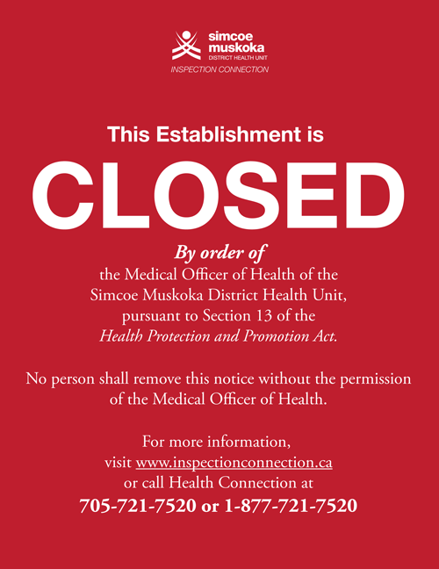
Will your practice survive a public health inspection ?

Live Webinar and Discussion Forum on Thursday, October 21, 2020 from 7:00 PM to 8:30 PM

1 AGD CE point in Category 2. Registration Fee $65.

Presented by Nicole Ross

Interviewed by Bassel P. Gebrael DDS, Dip. Perio, FRCD(C)

Nicol Ross is a Continuing Education Compliance Instructor and in-demand lecturer with extensive knowledge of Public Health, RCDSO, CDHO and related regulations as they relate to public health and infection control.

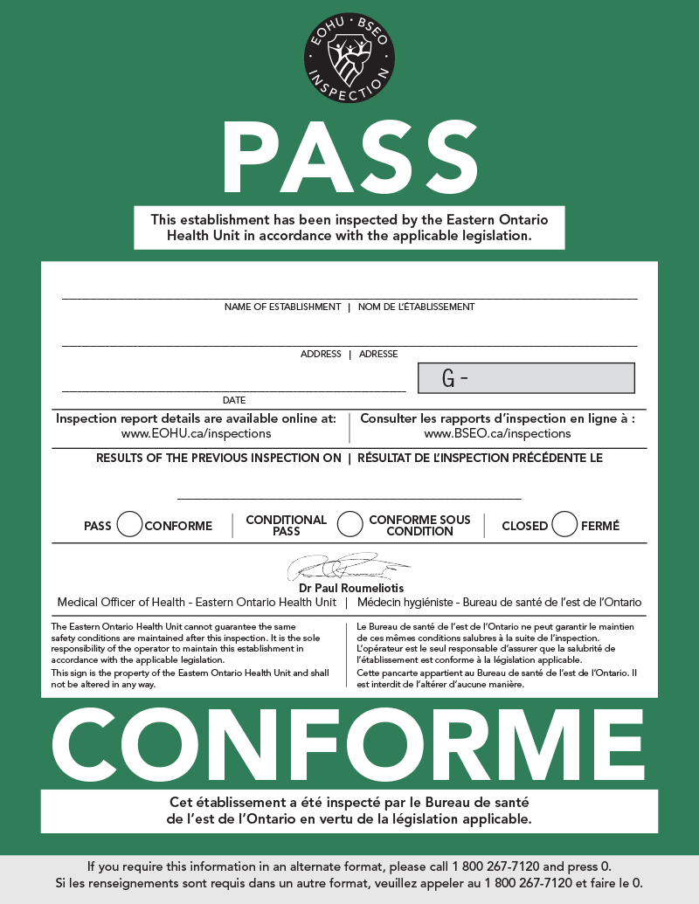

Course Objectives:

1) Learn how to manage dental unit water lines and how to monitor microbial contamination.

2). Review the proper use of a process challenging device (PCD) in infection control.

3) Learn how to test the effectiveness of your ultrasonic bath and dental dishwasher.

4) Learn how to maintain a one-way workflow from the dirty to the clean area to prevent cross-contamination.

5) Understand proper positioning and use of puncture-resistant sharps containers in each room.

6). Learn how to properly label and log the mechanical and chemical results for your sterilizers.

7) Learn the public health guidelines for live or artificial plants in your reception area.

8) Understand the content requirement and function of an IPAC manual in your practice.

9) Learn the value of having housekeeping receive training by an IPAC Officer on IPAC within your practice.

10) Learn the different gown and mask levels and how to provide them for your team members.

Click the button below to register.

If you miss the live session you will get a video link to watch later.
Please note: The URL of the webinar will be sent by email after registering.

SCIENCE OF IMPLANTS is designated as an Approved PACE Program Provider by the Academy of General Dentistry. The formal continuing education programs of this program provider are accepted by AGD for Fellowship, Mastership and membership maintenance credit. Approval does not imply acceptance by a state or provincial board of dentistry or AGD endorsement. The current term of approval extends from 9/1/2020 to 8/31/2024. Provider ID# 365586

